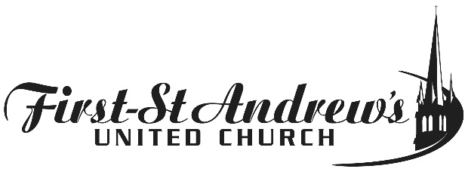

Great Things Happen Here – thanks to YOU!
Giving by PAR (Pre-Authorized Remittance)

You can arrange for your donation to be made automatically by using Pre-Authorized Remittance (PAR) – this is the recommended, easiest, and most convenient way to donate.

It provides the church with much needed funds regardless of whether you can attend church.

Your givings make a difference! They pay for the programs and services offered by FSA – programs and services that are welcoming, inclusive and community-building!
Thanks for doing your part.

Sincerely,
FSA Stewardship Working Group

PRE-AUTHORIZED REMITTANCE (PAR) FORM
(For new PAR donors and to make changes to payment details)

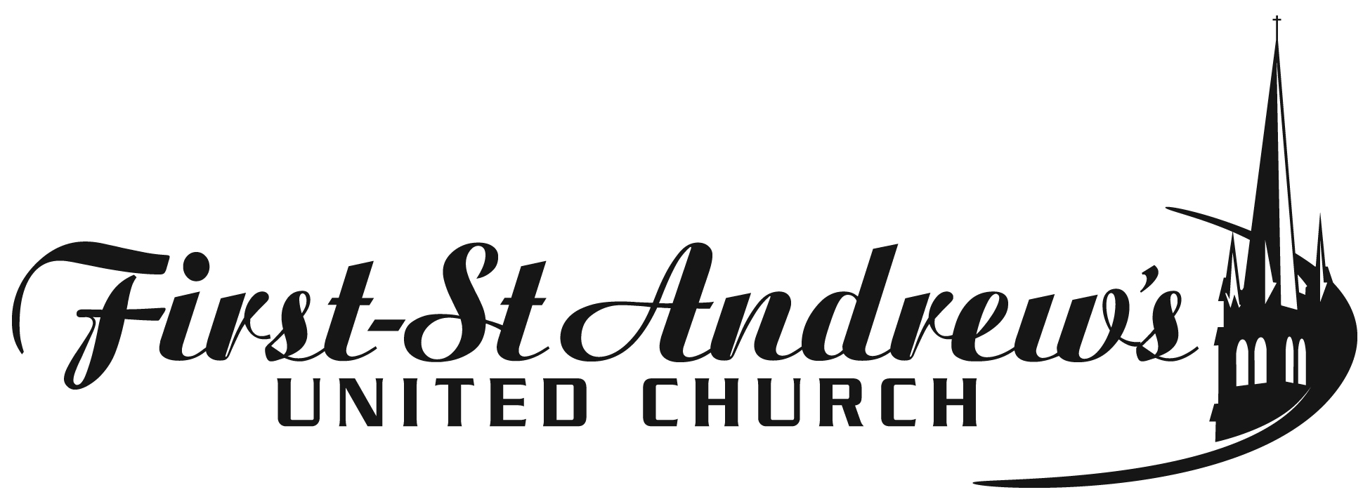

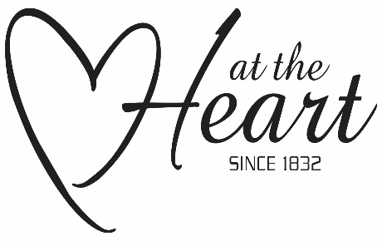
Church Name:

I/We, request and authorize The United Church of Canada to debit my/our account on the 20th of every month in the amount of $ , starting on the 20th of (enter month/year). This contribution is made on behalf of:
First-St. Andrew’s United Church, 350 Queens Ave., London ON, N6B 1X6.

This contribution by me/us to the above local church is to benefit:
Amount to help operate FSA: _____ Amount to help M&S: ______

Amount to *Other: *Please specify: __

New PAR donors, please attach a VOID cheque.

OR

Credit Card #: ______ _____ _________ Visa: __ MC: ___ Expiry Date: ______________

Signed: Date:
- I may change the amount of my contribution at any time subject to providing notice of 15 days.
- I may revoke my authorization at any time by contacting the Office Manager at First-St. Andrew’s United Church, subject to providing notice of 15 days. Contact may be by mail, phone (519-679-8182) or email (admin@fsaunited.com).
- I have certain recourse rights if any debit does not comply with this agreement. For example, I have the right to receive reimbursement for any debit that is not authorized or is not consistent with this PAR agreement. To obtain more information on my recourse rights, I may contact my financial institution or visit www.cdnpay.ca.
- I waive my right to receive pre-notification of the amount of the Pre-Authorized Remittance (PAR) and agree that I do not require advance notice of the amount of PAR before the debit is processed.

RETURN COMPLETED FORM TO: Kathryn Skelly, Office Manager, FSA
Phone: 519-679-8182
Email: admin@fsaunited.com

We agree to be bound by, comply with, respect and apply all relevant provisions of the Canadian Payments Act and all related by-laws, rules and standards in force from time to time as they apply to PAR’s including, without limitation, the Confirmation/Pre-notification requirements or waiver of Pre-notification requirements and cancellation requirements as set out in Rule H1.

The use, retention and disclosure of personal information collected from this form is done in compliance with privacy legislation, including but not limited to, the Personal Information Protection and Electronic Documents Act (2000, c5).

