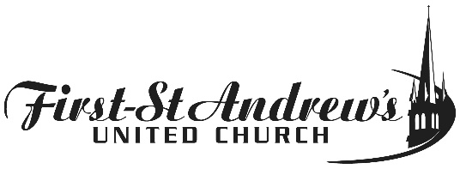

Jean Brown Fund Proposal Form
“funds are available for youth work within the congregation”

Name of group or person requesting funds __________
Amount requested
What will the funds be used for?
How many youth will be involved or impacted?

Is this for an ongoing project or a one-time event?

Who will oversee the distribution and implementation of the money requested? ___ __

Please submit proposals to Allyson Watson before November 1, 2017

