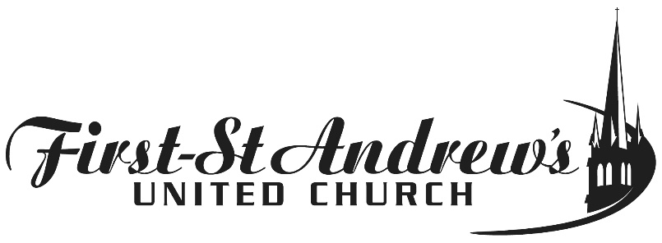

Photo Release Permission Form

I, , give my permission for photos and videos of me while participating in
(Name of Event)
at First-St. Andrew’s United Church to be used and displayed and/or to promote future events in print, PowerPoint, and on Social Media, among other formats.

Name:
Signature:
Date:
350 Queens Avenue at Waterloo
519-679-8182 · www.fsaunited.com

